Using Drexel Technologies for Printing & Posting Bid Documents

- Contact Information: Distribution@drexeltech.com - 913.371.4430
- Architect/Engineer shall contact Drexel in advance to ensure that bid documents can be posted in a timely manner
- A/E shall upload files to Drexel early enough to allow the documents to be available in the plan room on the scheduled date
- A/E shall verify that the documents are posted to Drexel and available in the plan room. Large files have issues with uploading and emailing so the AE must verify that Drexel has the documents posted.
1. Go to the Drexel Technologies website: www.drexeltech.com

2. Click on Send Us Files
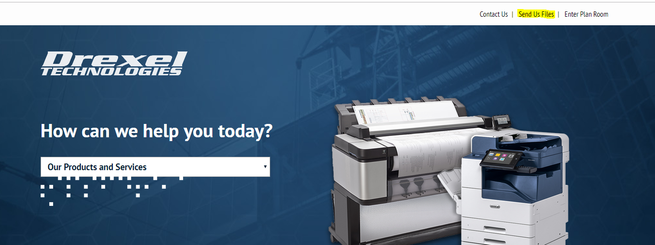
3. Click on the Lenexa Location
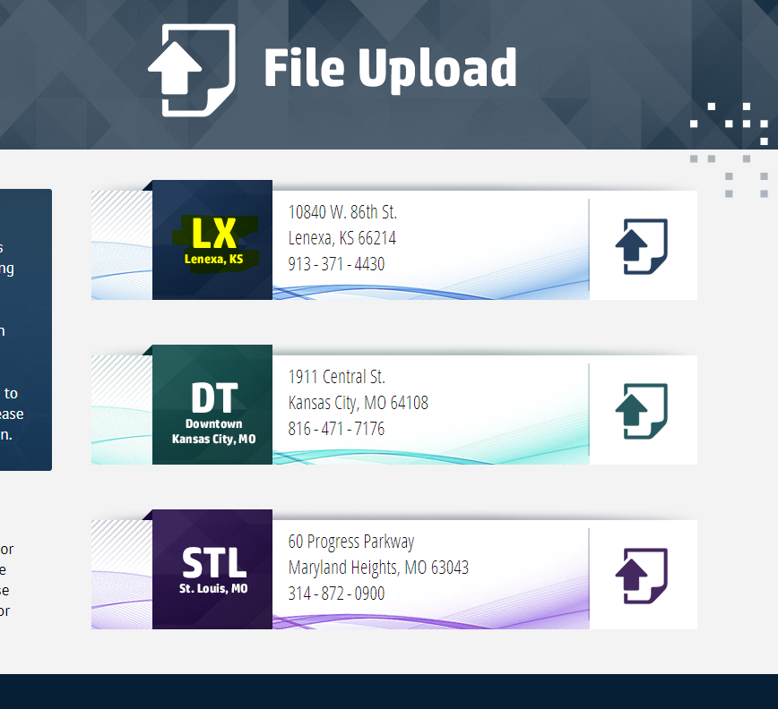

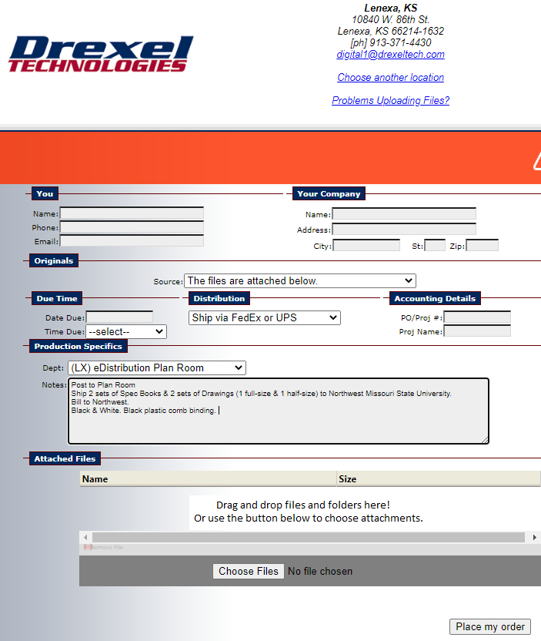
4. Fill in information
- Source: select “The files are attached below”
- Distribution: select appropriate method.
- Dept: Select eDistribution Plan Room
- Notes: Enter the number of sets of spec books and drawings needed here. Confirm quantities with Northwest Project Manager. Specify black and white or color. Specify black plastic comb binding. Northwest’s copies should be sent to Northwest via FedEx & billed to Northwest.
5. Attach Files
Click on “Choose Files” and select files. The selected files will be listed.
6. Click on “Place my Order.”
You will get a pop-up message that the files are being uploaded and a separate message when the upload is complete.
7. You will receive a confirmation email.
Go to the plan room to verify that the bid is listed, information is accurate, and documents are available.
